# Title: On “Допомогти фінансово” page. When clicking on a “Допомогти фінансово” button, we appear on the same page.

**Priority:** High

**Severity:** S4 Minor

**Environment:**Samsung Galaxy J7 Neo (720x1280 pixels, Android 9 OS)

**Steps to reproduce**

1. Open the Main page: [https://kmlvm.kyivcity.gov.ua](https://kmlvm.kyivcity.gov.ua/)

2. Slide to a “Благодійна допомога тваринам” section on the Main banner-carousel.

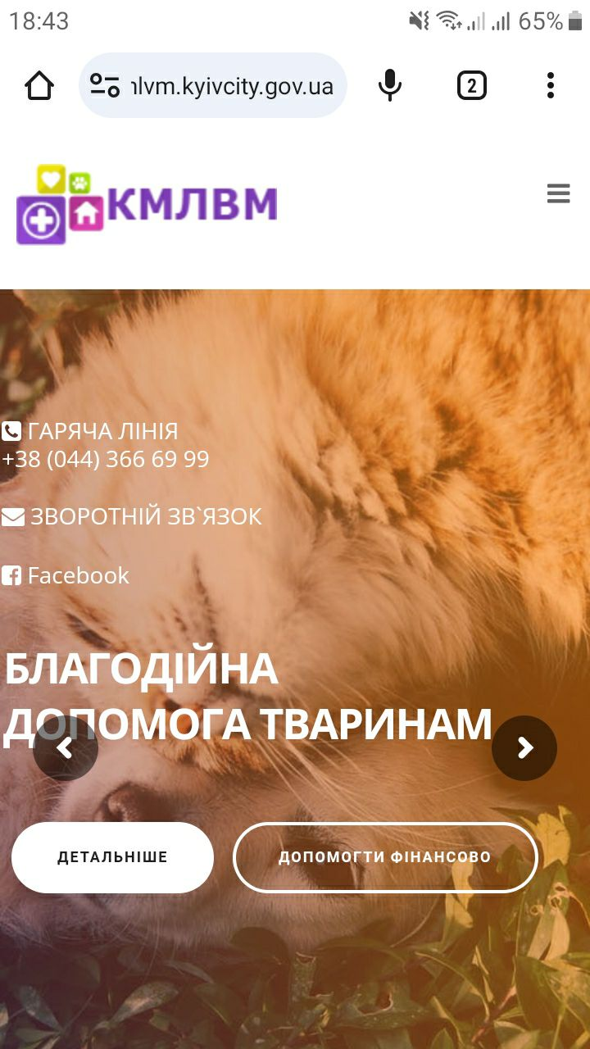

3. On this section click “Допомогти фінансово” button.

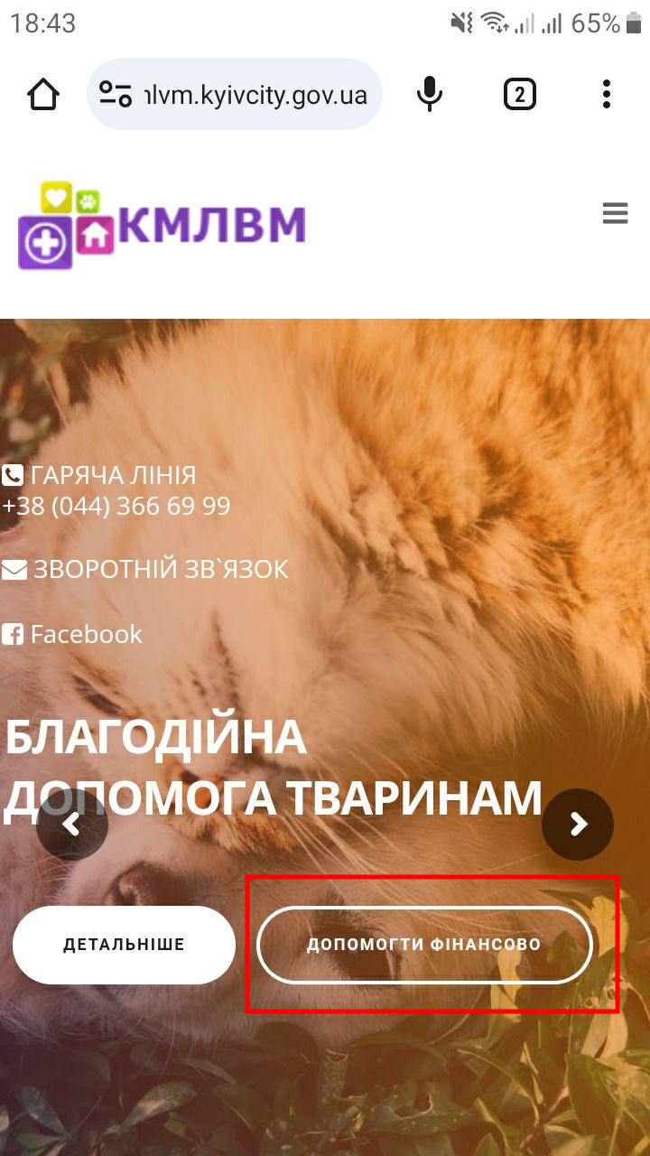

4. On an opened page, named “Допомогти фінансово” click on a rectangle button “Допомогти фінансово”.

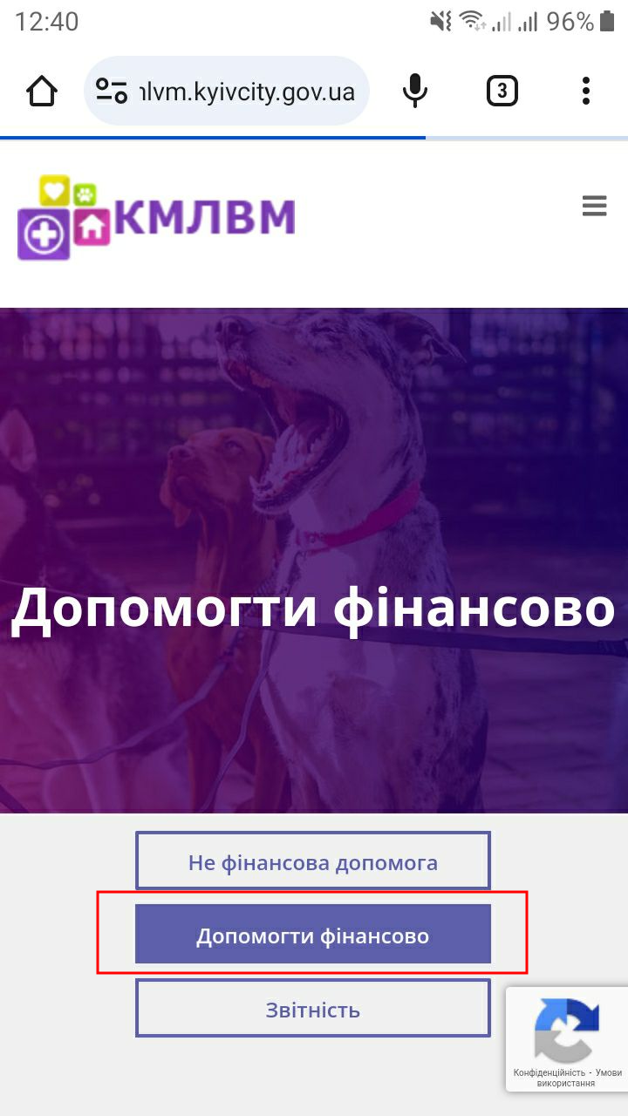

**Actual result**

We appear on the same page, named “Допомогти фінансово”.

**Expected result**

There must be opened another page or another part (“anchored”) of the same page. Or this button must be deleted.

*Screenshot from* ***Jira****:*